Scan to Salesforce User Guide

Mobile app
- Download and install the Scan to Salesforce mobile app.
Go to App Store (iOS) or Google Play (Android).
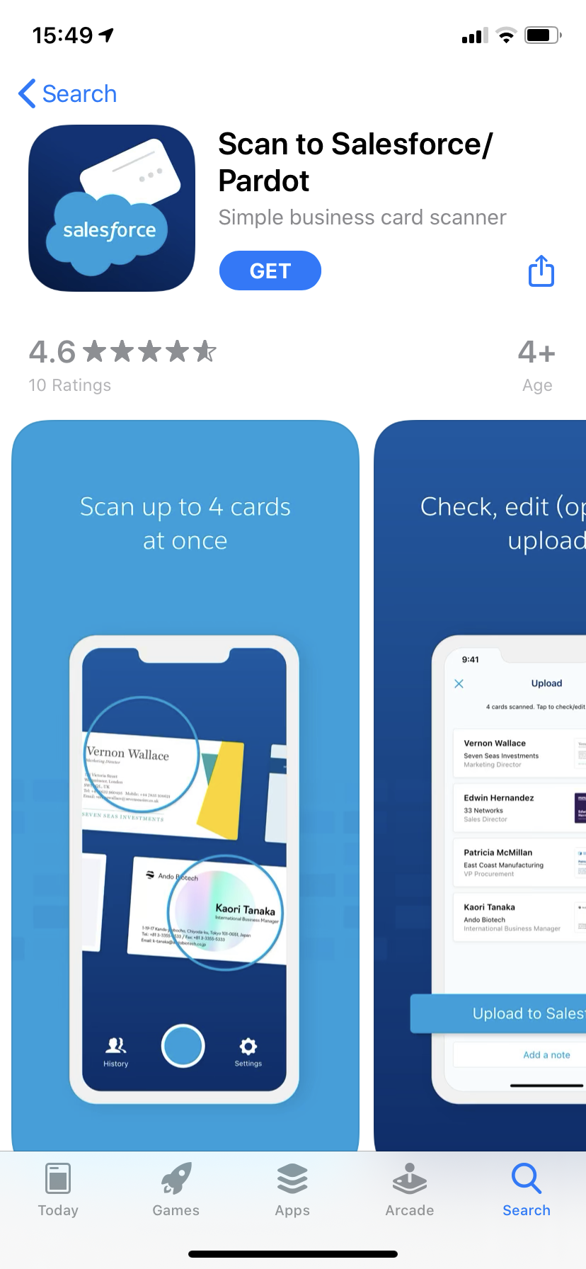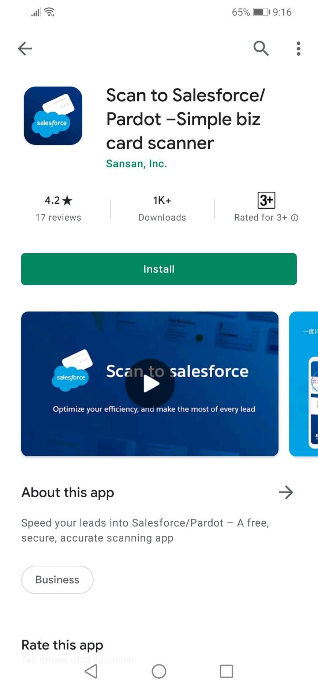

- Connect with Salesforce
You’ll need to log into your Salesforce account when you use the app for the first time.
*To log in with a custom domain, use “(domain name).my.salesforce.com”.
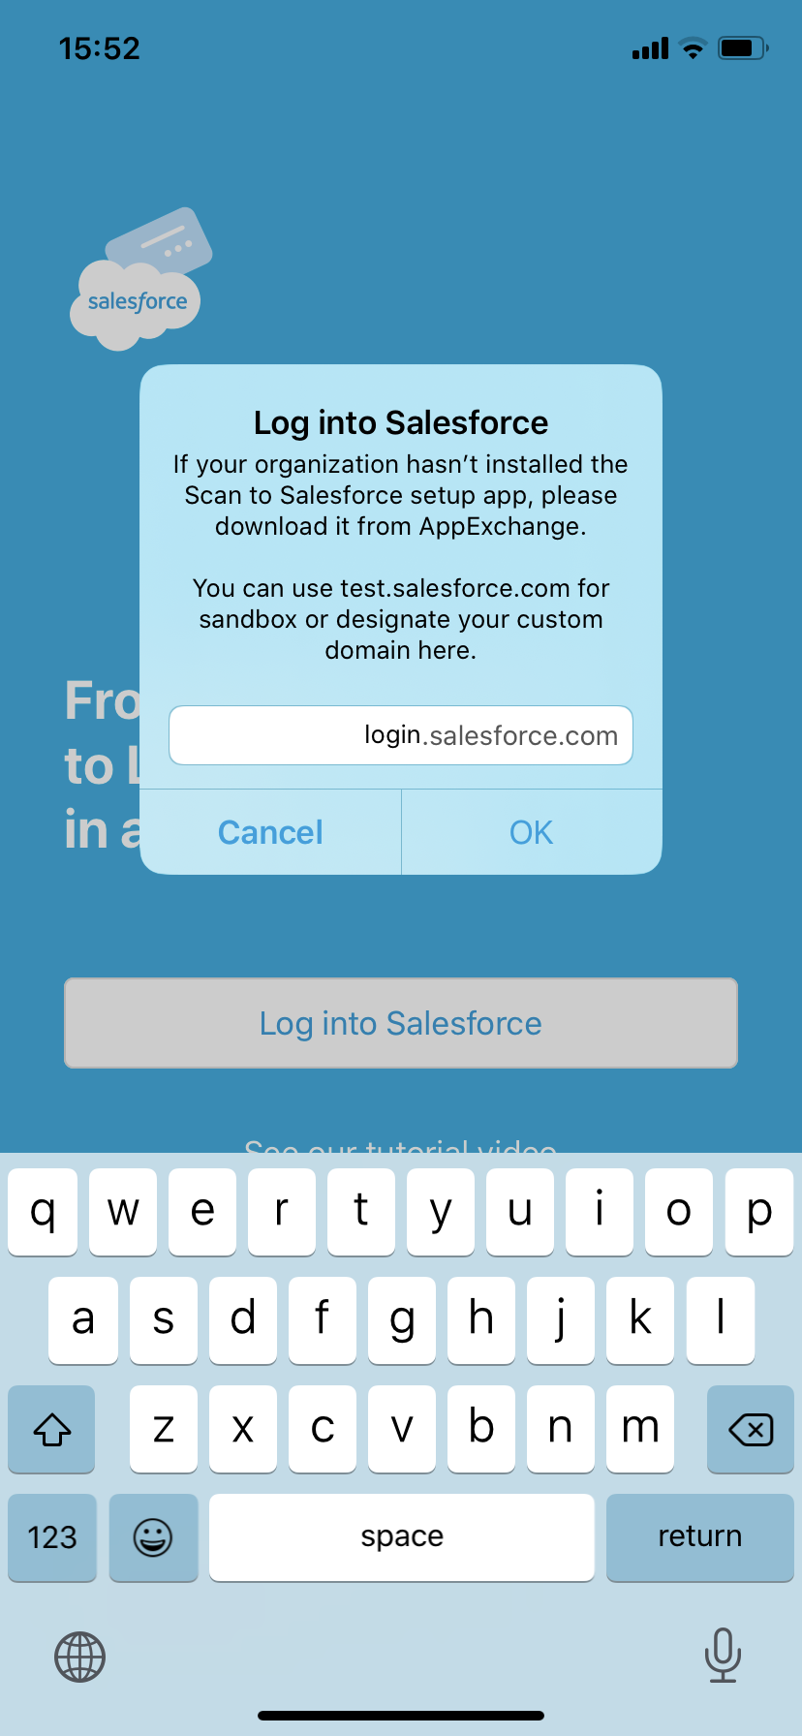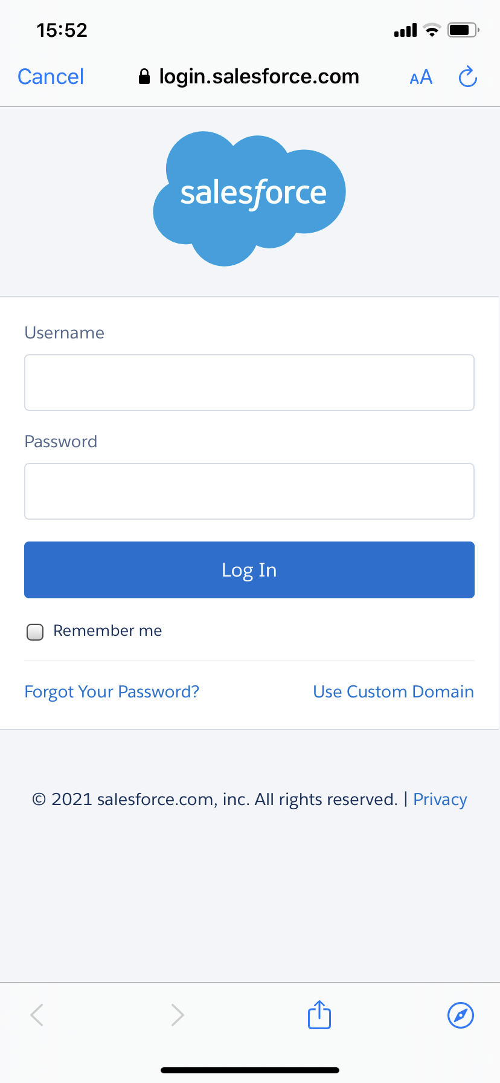

- Scan business cards
3-1. Business cards

Standard Scan: Standard Scan mode lets you digitize up to 4 cards in one shot. Place the cards on a flat surface with a solid background. Then tap the shutter button when you see a blue circle at the center of each card.
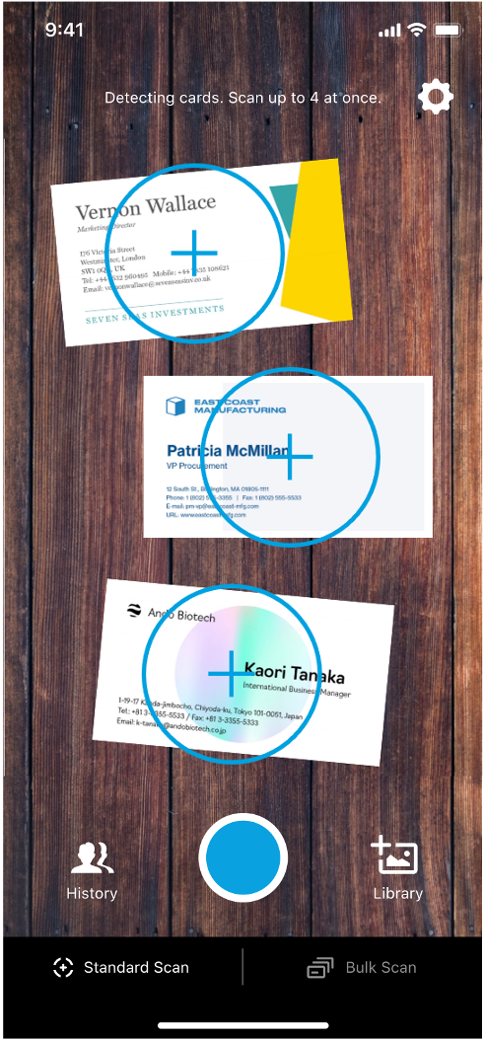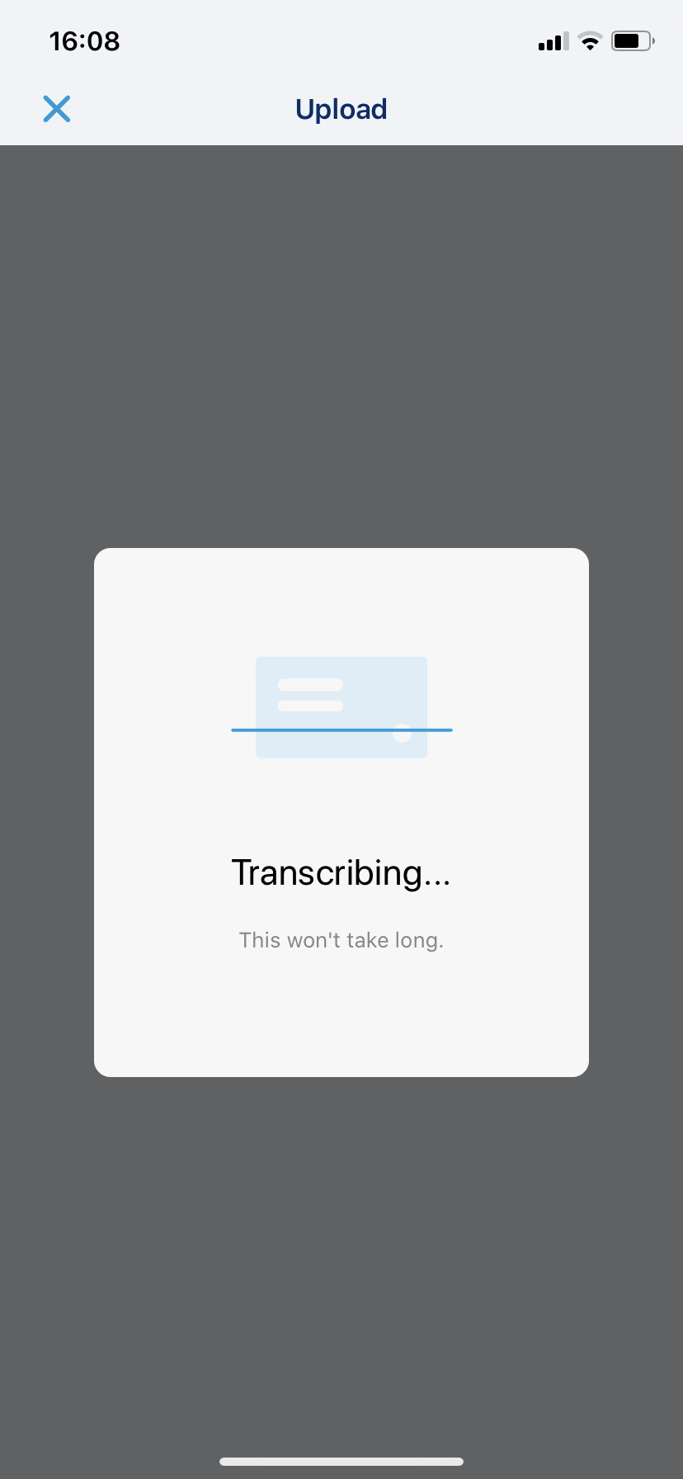

Bulk Scan: Tap Bulk Scan in the bottom right corner to scan multiple cards continuously. Tap Done to start digitizing them.
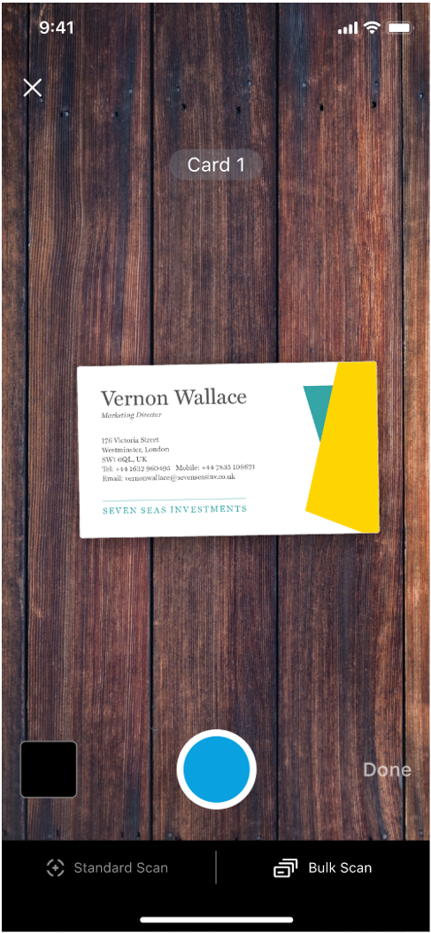

3-2. Saved business card images/photos
Tap Library in the bottom right corner. Then select the image of the card you want to process.
Align the card within the borders. Tap Done to start digitizing.
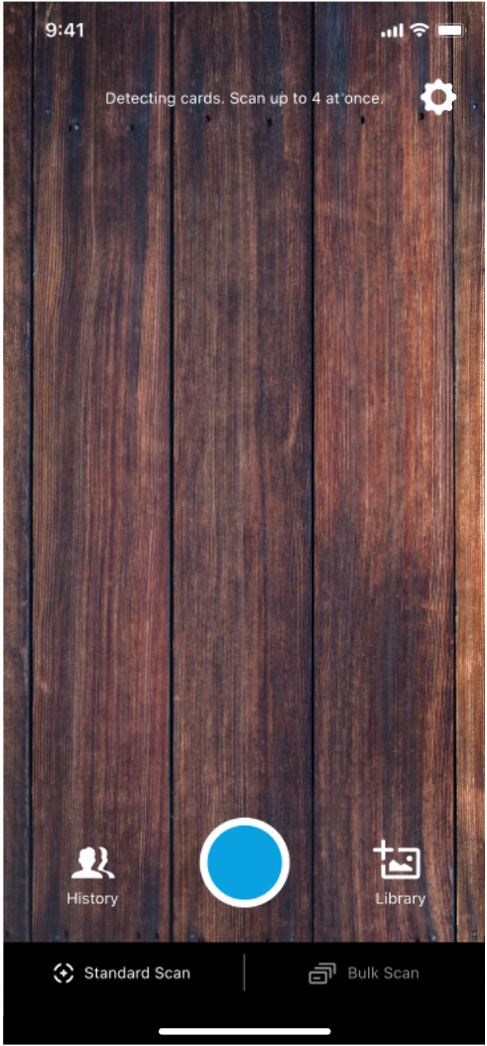

- Confirm the scanned data and add context
Tap on a card to check the scan output. If necessary, edit the details and add notes for additional context. Include the card’s back/reverse side using Attach Image.
*On the editing screen, you can pinch and zoom to magnify the card image.
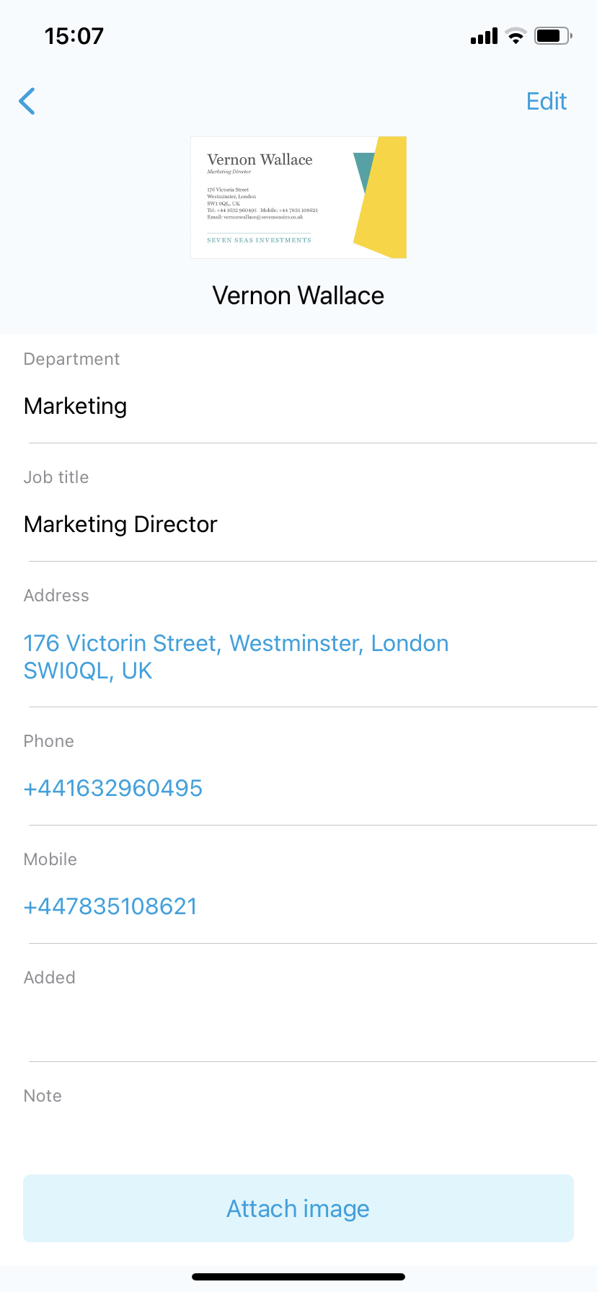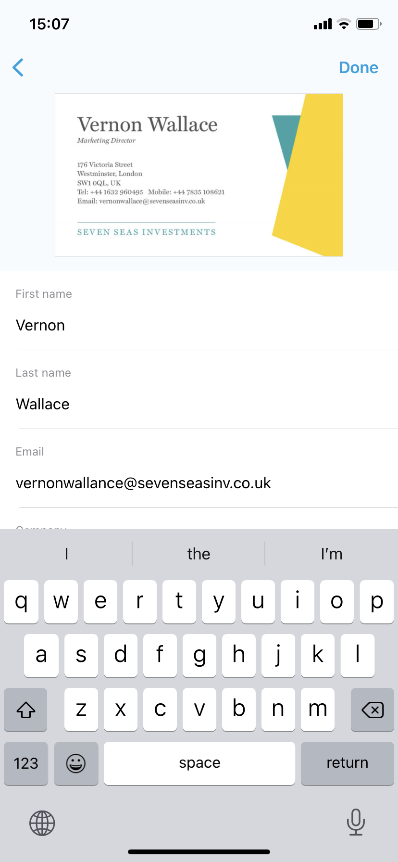

- Upload cards to Salesforce
Tap Upload to Salesforce to transfer the card data.
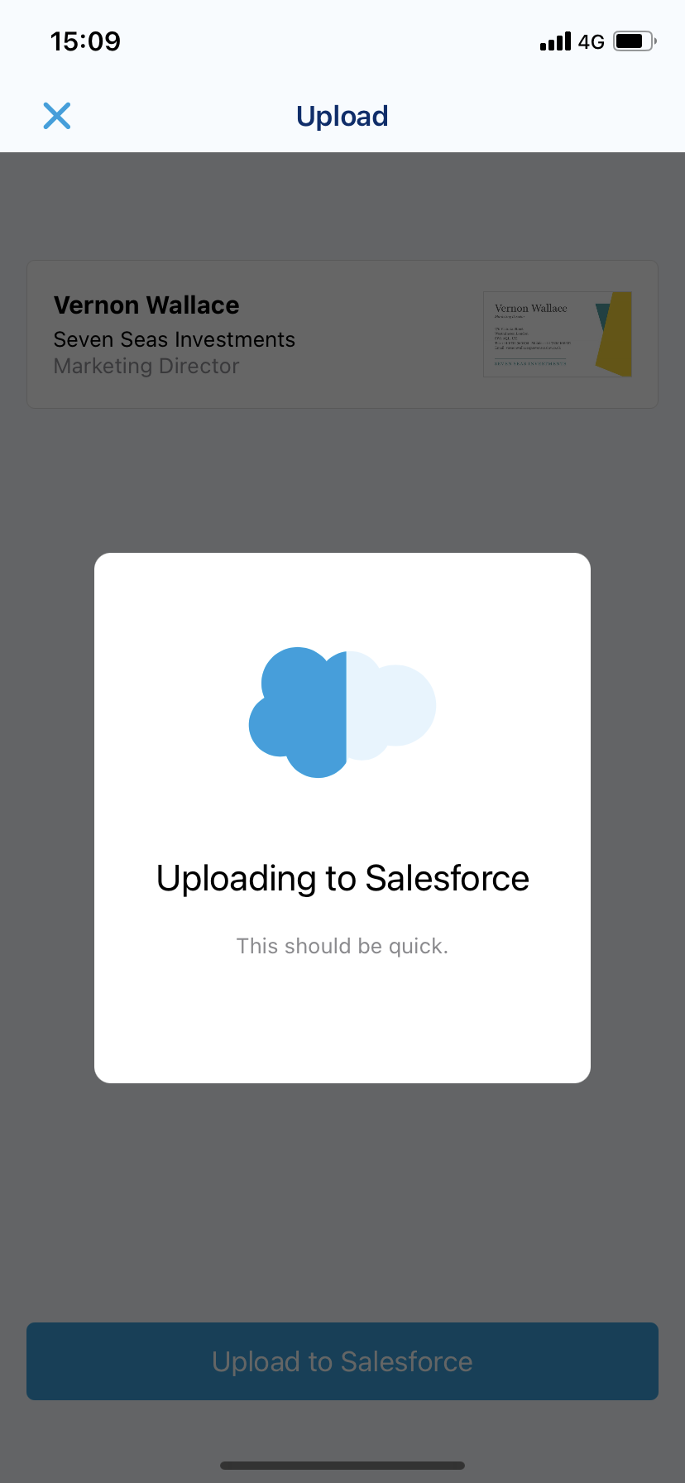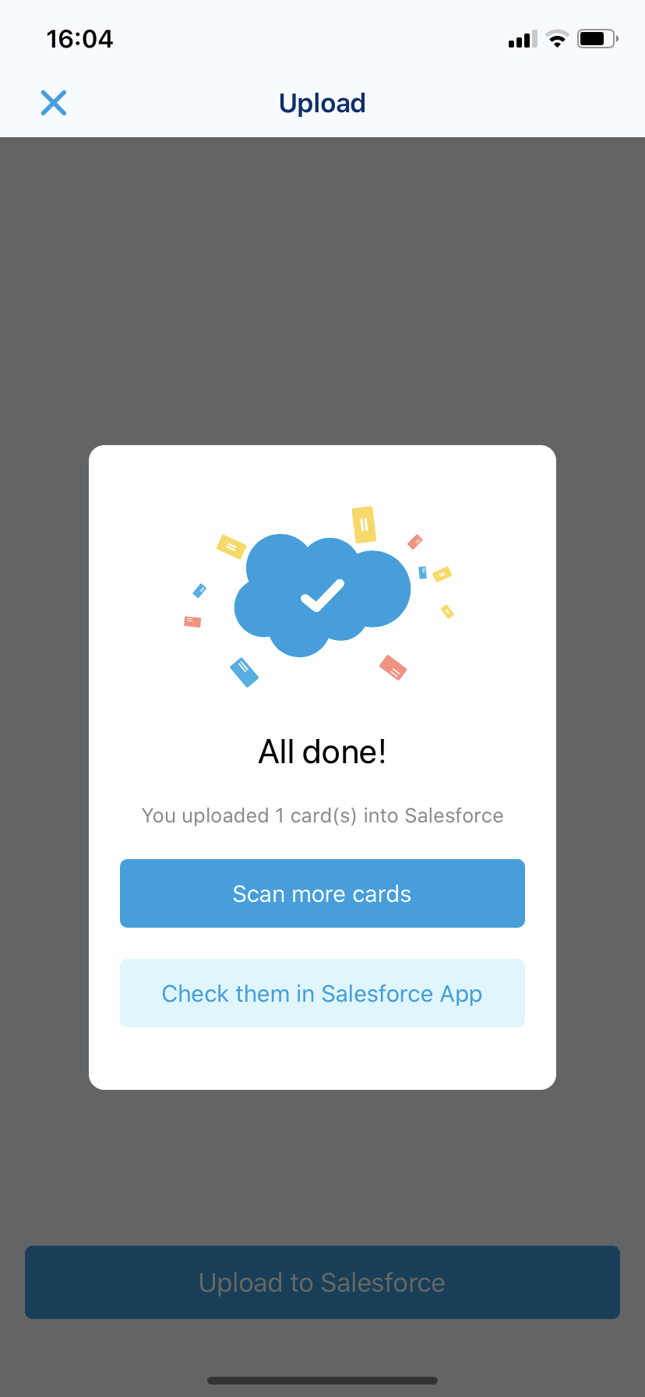

Salesforce app
- Open Scan to Salesforce in the Salesforce dashboard
Click Scan to Salesforce in the Salesforce App Launcher.
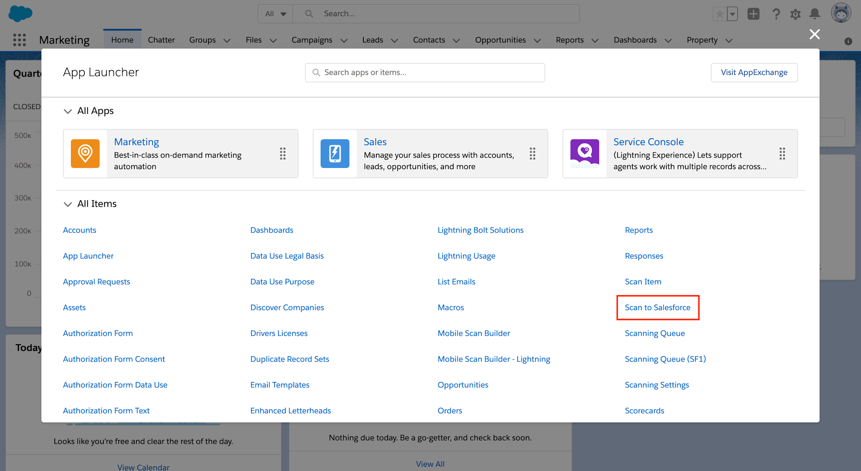

- Find your uploaded cards
In the Scan to Salesforce tab, you can confirm and edit your uploaded card data.
*You can sort cards by upload date and time.
**If available, use All users’ cards to see cards uploaded by other users in your org.

- Transfer business cards
Click Transfer to Leads to transfer data. If your admin allows it, you can change the transfer destination to Contacts by selecting Transfer cards to Contacts. If Scan to Salesforce can find identical Account data in your Salesforce org, scanned data will be automatically associated with it. If no match is possible or multiple matches are found, you can choose either to create a new Account or manually associate with an existing Account.

- Check transferred card data
Open Leads from the App Launcher and confirm the transferred cards.

- Check transferred card data
After card data is transferred, check how many business cards were transferred. From the top right of the Salesforce app, click the Display Report button and see how many Leads and Contacts were created each month.
*Admins can also disable the report view mode, and the Display Report button will then not be shown.
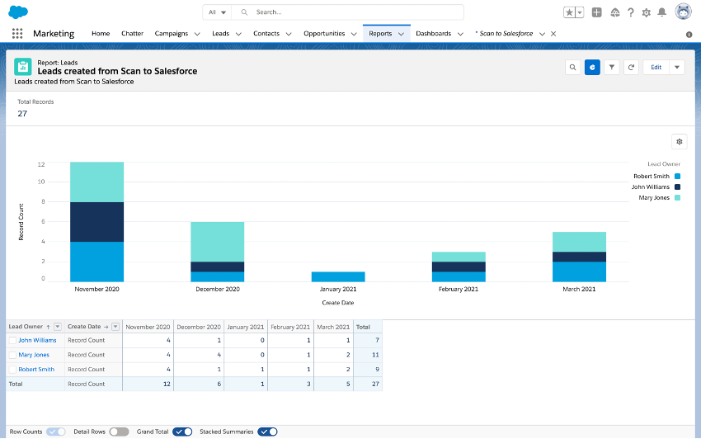

Need some support?
We’ve put together simple troubleshooting videos that address common problems you may have. If you still need help, feel free to contact us. Hope these instructions help! Enjoy scanning!

